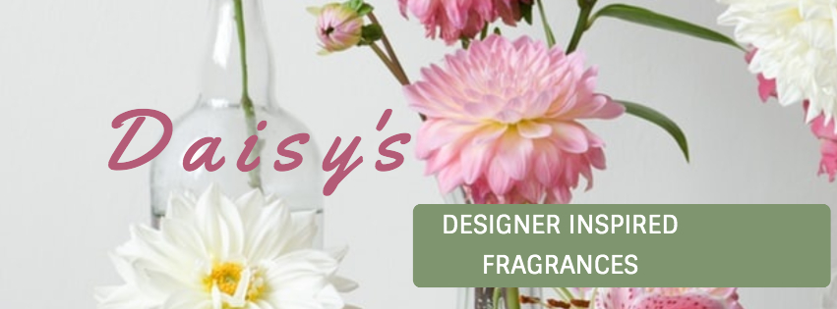

Thank you so much for your Purchase
It is very much appreciated

I hope you will enjoy your
Perfume
and will come back again soon

https://www.facebook.com/DaisyDesignerInspiredFragrances

If you would be interested in becoming an
Essens Distributor
go to this link

https://www.essens.co.uk/r-680042132

or email me for more information
mo@thepages.me.uk

Maureen Page
18 Corporal John Shaw Court
Prestonpans
Mob: 07951863343



Fill in the Joining Form Online

Click on the "Join Now" button below, which will take you to the registration form.

Then fill in your details. Degree is your Title (e.g. Mr, Mrs or Miss) and National Identification number is your NI number although this field can be left blank.

Next Steps
You will receive an email with your user name and PIN number. This will enable you to log into your member website online. It is so important to keep this number safe so please make sure you enter the correct email address when registering with Essens.

We will contact you within 24 hours to welcome you and give you further information and appropriate training if you require it. Please get in touch if you have any questions. I can be contacted here and I'm always happy to hear from you.

